**Operational Amplifiers**

Table of Contents

Inverting Amplifiers 3

Non-Inverting Amplifiers 4

Summing Circuits 5

Difference Circuit 6

Integrating Circuits 7

Differentiating Circuit 8

Instrumentation Amplifier 9

CMRR and CMR 11

Basics of Operational Amplifiers 12

Comparators 13

Schmitt Trigger 15

Differential and Common Mode Operation 16

Operational amplifiers are specially designed amplifiers in bipolar or CMOS with the following typical characteristics:

* Very high gain (10,000 to 1,000,000)
* Differential input
* Very high (assumed to be infinite) input impedance
* Single ended output
* Very low output impedance



An operation amplifier is made up of 15-20 transistors, typically MOSFETs and BJTs. There are 5 terminals, along with the 2 inputs and the output should be obvious. The other two terminals, $V_{S}+$ and $V_{S}-$, exist to provide power to the op-amp.

## Inverting Amplifiers

One of the several ways in which an operational amplifier can be connected is as an inverting amplifier.



Here, the input signal is sent to the inverting terminal, which causes the output to be an inverted version of the input. Some energy from the output will be fed back to the input via the feedback resistor, $R_{F}$. This causes some amplification.

$\frac{V_{out}}{V_{in}}=-\frac{R_{F}}{R}$ gives us the amount of amplification.

$Z_{in}=R_{1}$ gives us the input impedance.

$Z_{out}=0$ gives us the output impedance.

## Non-Inverting Amplifiers



In non-inverting amplification, the input is connected to the non-inverting terminal. This cause the output to just be an amplified version of the input.

$$\frac{V_{out}}{V_{in}}=1+\frac{R_{F}}{R}$$

$$Z_{in}=∞$$

$$Z_{out}=0$$

## Summing Circuits

Summing circuits can be used to add up analogue signals.

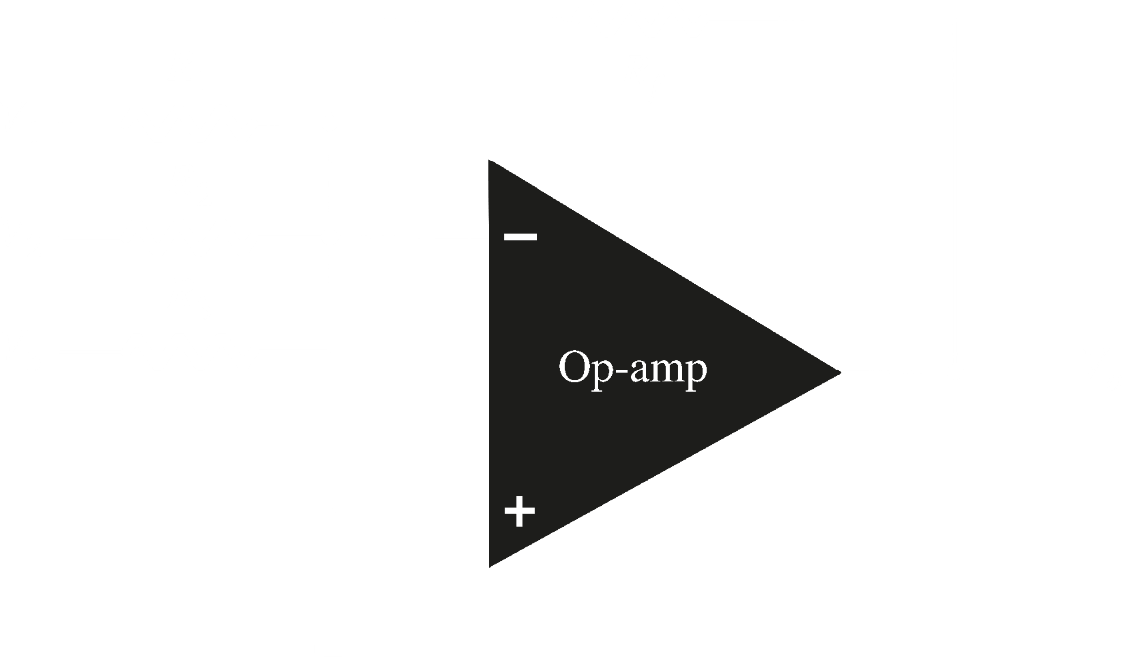

Note that the three inputs shown here do not form a parallel circuit. The inputs come from separate lines. Also, the output in this case will be the sum of the inputs, but inverted, since we have connected the inputs to the inverting terminal.

The gains, or amplification factors, or each of the inputs can be calculated as:

$A_{CL1}=-\frac{R_{f}}{R_{1}}$ $A_{CL2}=-\frac{R_{f}}{R_{2}}$ $A_{CL3}=-\frac{R_{f}}{R_{3}}$

$$V_{o}=V_{in}⋅A_{CLn}$$

$$V_{o}=-V_{1}⋅\frac{R_{f}}{R_{1}}-V_{2}⋅\frac{R_{f}}{R_{2}}-V_{3}⋅\frac{R_{f}}{R_{3}}$$

If all the resistors are equal in value, $V_{o}=-\left(V_{1}+V_{2}+V_{3}\right)$

## Difference Circuit

Difference circuits are used to subtract analogue signals.



In this circuit, the input connected to the inverting terminal, $V_{1}$, is subtracted from the input connected to the non-inverting termina, $V_{2}$.

$$V_{out}=\frac{V_{1}\left(R_{3}+R_{1}\right)R_{4}}{\left(R_{4}+R_{2}\right)R_{1}}-\frac{V_{2}R_{3}}{R_{1}}$$

If all resistors are equal, $V_{out}=V_{2}-V_{1}$

## Integrating Circuits

An integrating circuit allows us to perform integration operations.

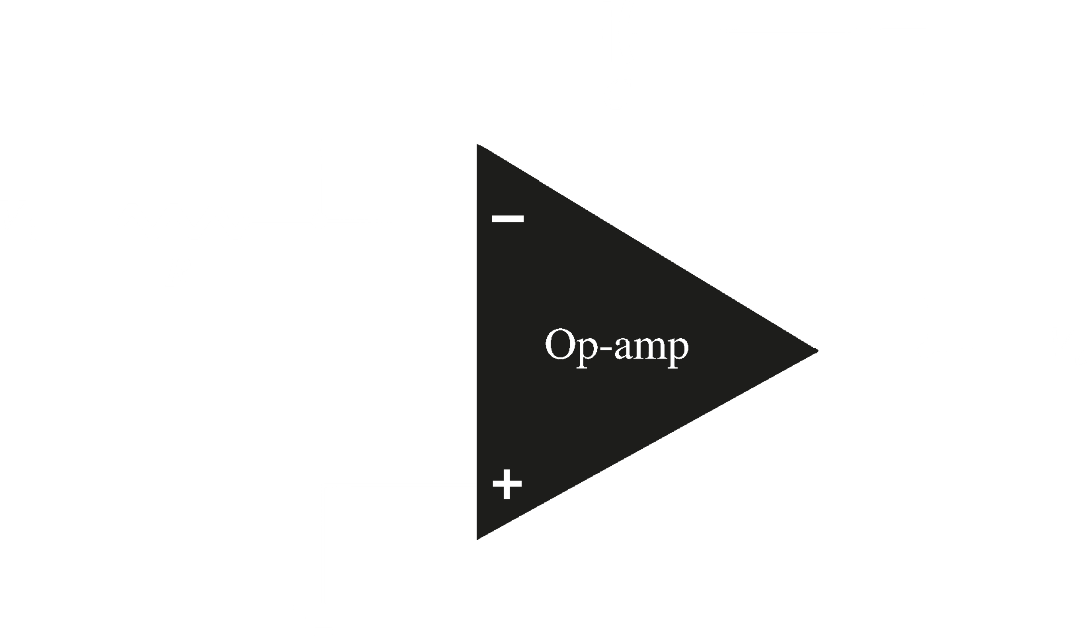

Notice that a capacitor is used in place of a resistor in the feedback path.

A constant input signal to the input will generator a certain rate of change in the output voltage. The signal is smoothed over time.

$$\frac{d_{v_{out}}}{dt}=-\frac{V_{in}}{RC}$$

or

$$V_{out}=\int_{0}^{t}{-\frac{V_{in}}{RC}dt+c}$$

where $c$ is the output voltage at $t=0$.

## Differentiating Circuit

A differentiating circuit allows us to perform differentiation operations.

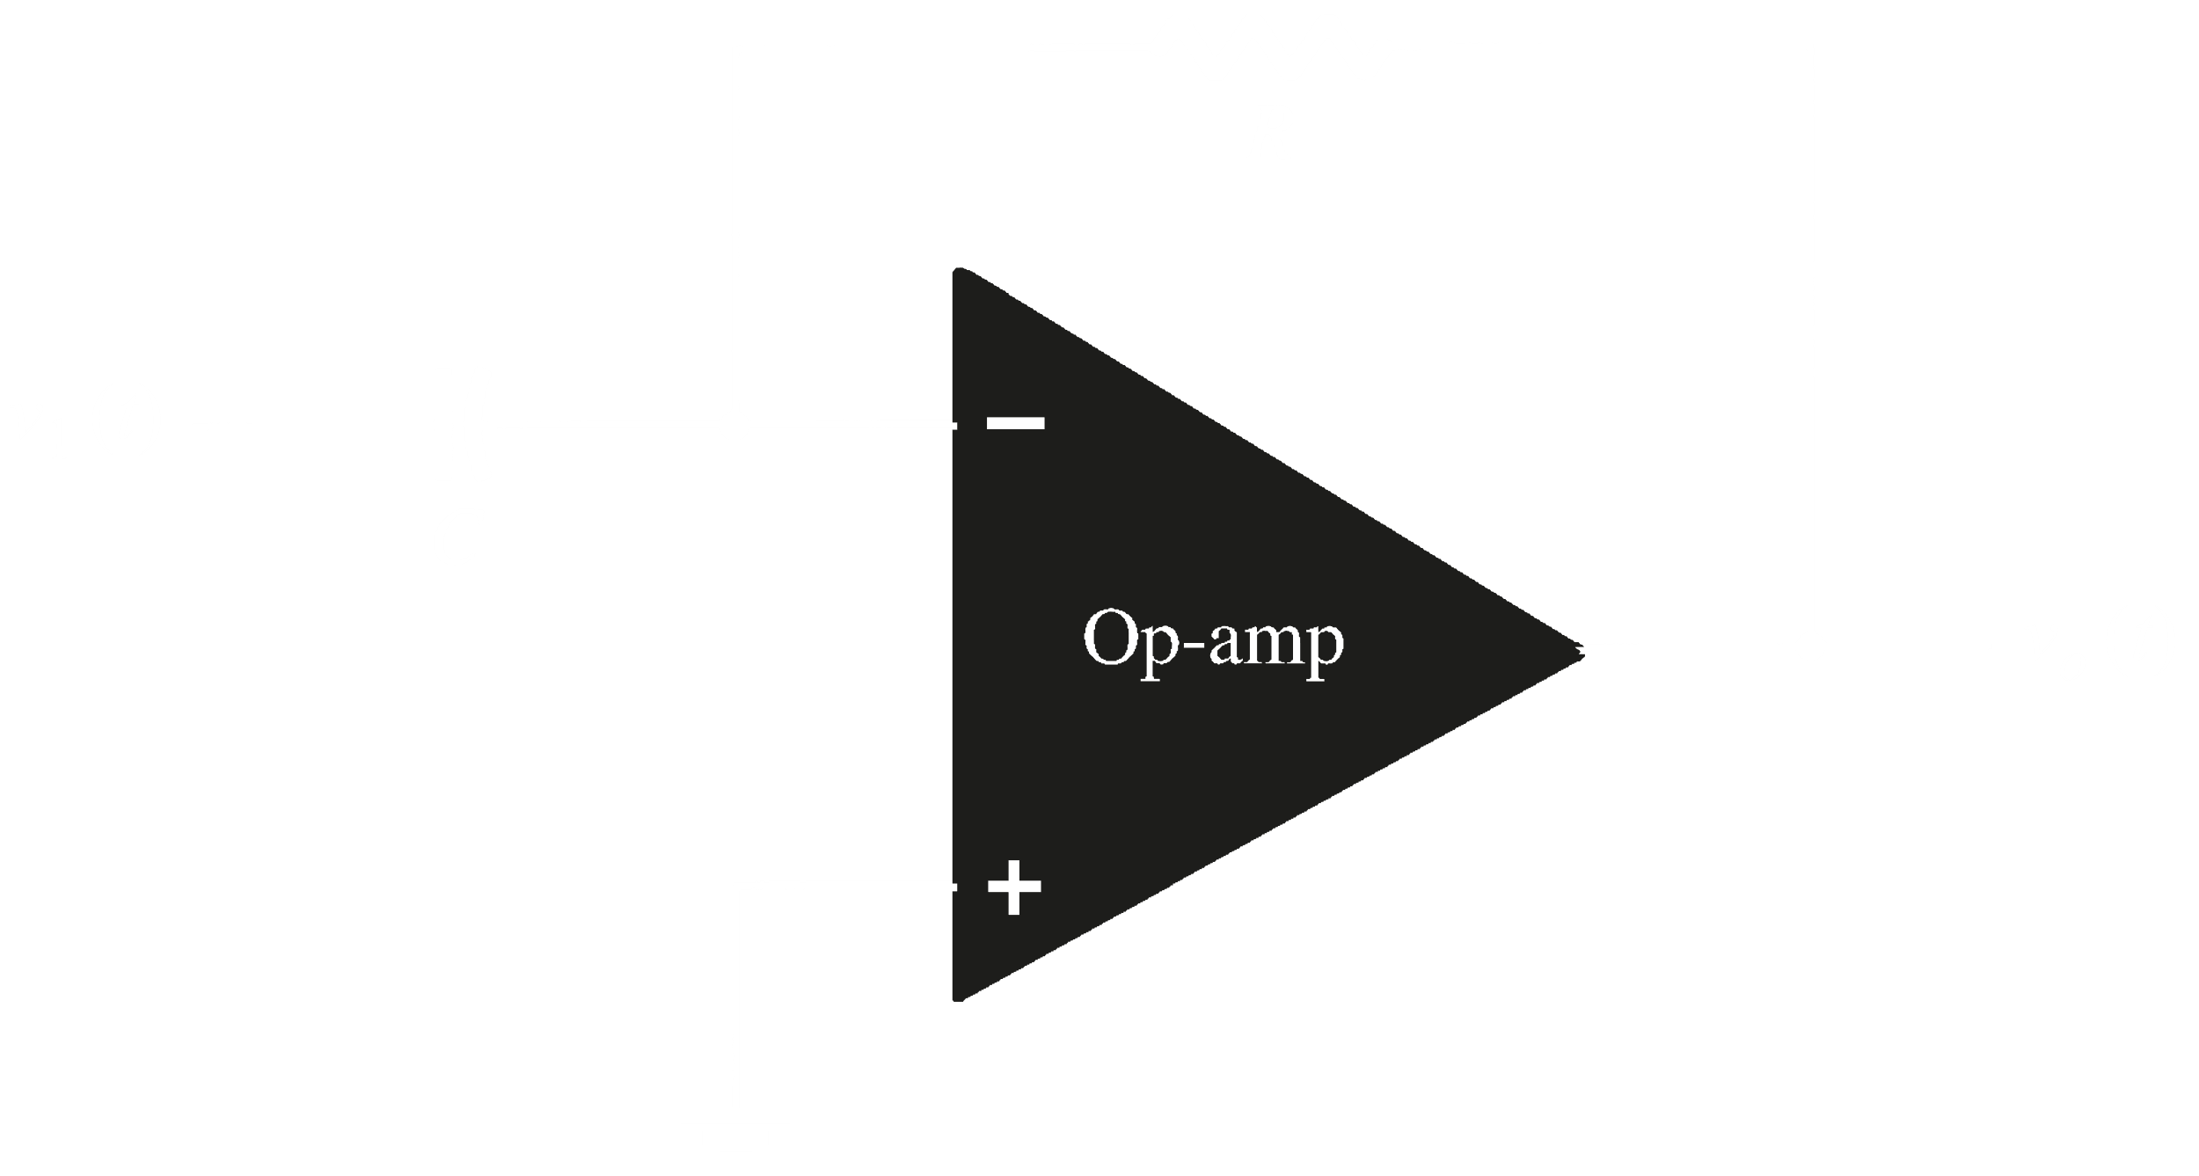

Notice that a capacitor has replaced the resistor in the input path at the inverting terminal.

The signal processing method causes noise to be increased over time.

The output signal is the scaled derivative of the input signal.

$$V_{out}=-RC\frac{{d v}_{in}}{dt}$$

## Instrumentation Amplifier

Instrumentation amplifiers have a wide variety of applications, such as in medical equipment.

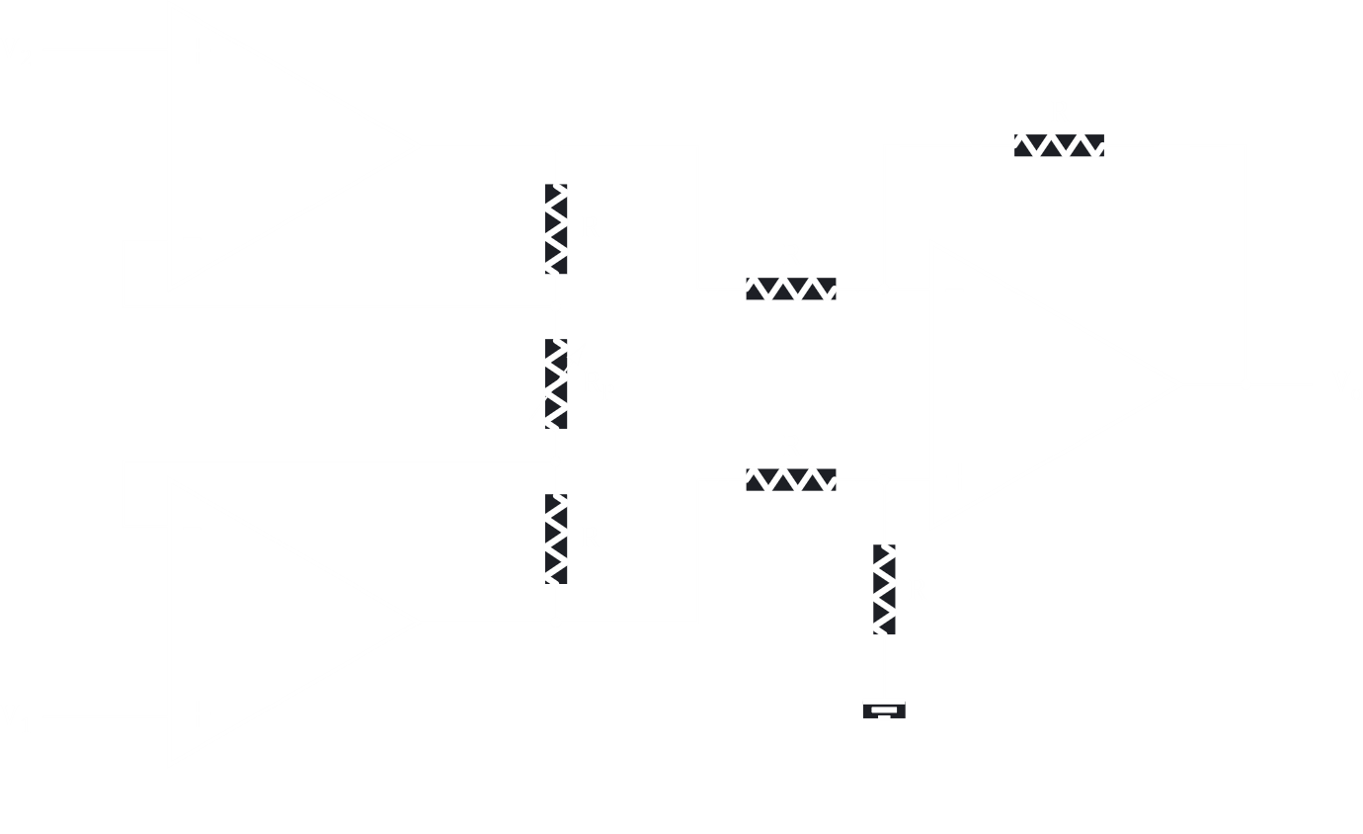

In the above circuit, there are three operational amplifiers. $A_{3}$ is the one from which an output is taken, and that is a difference circuit. The inputs for this circuit are coming from $A_{1}$ and $A_{2}$, which are not difference circuits. $A_{1}$ is performing an inversion, while $A_{2}$ is not.

$$v_{o1}-v_{o2}=\frac{v_{1}-v_{2}}{R_{1}}R_{2}+v_{1}-v_{2}+\frac{v_{1}-v_{2}}{R_{1}}R_{2}$$

$$=\left(v_{1}-v_{2}\right)\left[\frac{R_{2}}{R_{1}}+1+\frac{R_{2}}{R_{1}}\right]$$

$$=\left(v_{1}-v_{2}\right)\left[1+\frac{2R_{2}}{R_{1}}\right]$$

In the difference amplifier,

* The inverting amplifier produces $v_{oi}=-v_{o1}\left[\frac{R_{4}}{R_{2}}\right]$
* The non-inverting amplifier produces $v_{on}=v_{o2}\left[\frac{R_{4}}{R_{3}+R_{4}}\right]\left[1+\frac{R_{4}}{R_{3}}\right]$
* The output is the sum of the outputs produced by each input

$$v_{out}=v_{oi}+v_{on}=v_{o2}\left[\frac{R_{4}}{R_{3}+R_{4}}\right]\left[1+\frac{R_{4}}{R_{3}}\right]-v_{o1}\left[\frac{R_{4}}{R_{3}}\right]$$

$$=v_{o2}\left[\frac{R_{4}}{R_{3}+R_{4}}\right]\left[\frac{R_{3}}{R_{3}}+\frac{R_{4}}{R_{3}}\right]-v_{o1}\left[\frac{R_{4}}{R_{3}}\right]$$

$$=v_{02}\left[\frac{R_{4}}{R_{3}+R_{4}}\right]\left[\frac{R_{3}+R_{4}}{R_{3}}\right]-v_{o1}\left[\frac{R_{4}}{R_{3}}\right]$$

$$=v_{o2}\left[\frac{R_{4}}{R_{3}}\right]-v_{o1}\left[\frac{R_{4}}{R_{3}}\right]$$

$$=\left(v_{02}-v_{o1}\right)\left[\frac{R_{4}}{R_{3}}\right]$$

$$=-\left(v_{1}-v_{2}\right)\left[1+\frac{R_{2}}{R_{1}}\right]\left[\frac{R_{4}}{R_{3}}\right]$$

$$=\left(v_{2}-v_{1}\right)\left[1+\frac{R_{2}}{R_{1}}\right]\left[\frac{R_{4}}{R_{3}}\right]$$

For $R_{2}=R_{3}=R_{4}$, $v_{out}=\left(v_{2}-v_{1}\right)\left[1+\frac{R_{2}}{R_{1}}\right]$

Quite often, $R_{1}$ is a variable resistor that is used to set the gain and is denoted as $R_{g}$.

## CMRR and CMR

The common mode rejection ratio (CMRR) defines the rejection of the common mode signal, the signal that is common to both inputs, a.k.a. the noise. The actual rejection is done using an instrumentation amplifier. Without excellent CMRR, we cannot have a significant output. This concept is very important for equipment like medical equipment, where noise is a huge problem.

CMRR is defined as the ratio of the differential gain to the common-mode gain.

$$CMRR=\frac{A_{dm}}{A_{cm}}$$

CMR is the value of CMRR expressed in decibels.

$$CMR\left(dB\right)=20\log_{10}\left(CMRR\right)$$

CMR and CMRR are often used interchangeably.

## Basics of Operational Amplifiers

Consider the first configuration, a non-inverting one.



Here, if we want some amplification, we can set the amount of amplification by choosing $R_{1}$ and $R_{F}$ (not shown) carefully.

In the inverting configuration, the same amplification can be achieved, but with an inversion of the signal.



It is important to understand how summation, subtraction, differentiation, integration and comparisons are done using op-amps, the last of which was not discussed before.

## Comparators

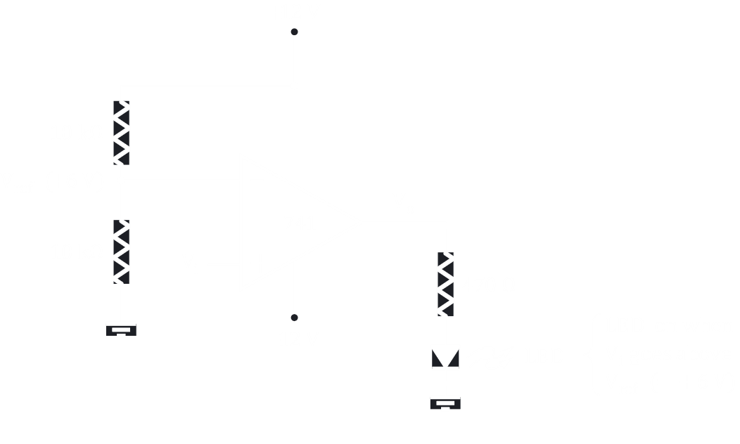

Comparisons are done against some benchmark. In the above diagram, this benchmark is $V_{REF}$. This value can be adjusted by adjusting the resistors connected in series with that point. In this case, since the two resistors are equal, $V_{REF}=\frac{V_{CC}}{2}$.



The way the comparator circuit works, up till the point where $V_{REF}>V_{IN}$, the non-inverting terminal is dominant, meaning there is an output. For the portion where $V_{IN}>V_{REF}$, the output is inverted, which results in us seeing a $0$ output, due to the LED being present.



## Schmitt Trigger

The comparison operation is utilized in Schmitt trigger. A simple comparator circuit uses an ordinary operational amplifier. It is extremely sensitive, which means if the input waveform is slow or has some noise in it, then a possibility arises that the output will switch back and forth several times during the switch over phase, since small levels of noise will cause the output to change.



This problem can be avoided by using a Schmitt trigger, which is a comparator with a positive feedback.



## Differential and Common Mode Operation

A differential circuit has an op-amp that provides an output component that is due to the amplification of the difference between the signals at the two inputs and another component that is due to the amplification of the common signals at both inputs. The amplification of the prior is much larger, which causes the circuit to essentially provide a common-mode rejection feature. This is described by the numerical value called the common-mode rejection ratio (CMRR).

When separate input signals are applied to the op-amp, the resulting difference signal is the difference between the two inputs.

$$V_{d}=V_{i1}-V_{i2}$$

When both input signals are the same, a common signal element due to the two inputs can be defined as:

$$V_{c}=\frac{1}{2}\left(V_{i1}+V_{i2}\right)$$

Since any signals applied to an op-amp generally have both in-phase and out-of-phase components, the overall output can be expressed as

$V_{o}=A_{d}V_{d}+A_{c}V_{c}$ where $A_{d}$ and $A_{c}$ are the differential gain and the common-mode gain respectively.

Ideally, opposite signals have no common elements and we can say

$$V_{i1}=-V_{i2}=V_{s}$$

Thus,

$$V_{d}=V_{i1}-V_{i2}=2V_{s}$$

$$V_{c}=\frac{1}{2}\left(V_{i1}+V_{i2}\right)=0$$

$$V_{o}=A_{d}V_{d}+A_{c}V_{c}=2A_{d}V_{s}$$

Thus, for inputs that are ideal opposite signals, the output is the differential gain times twice the input signal applied to one of the inputs.

If both inputs are ideal in-phase signals with no difference elements, $V_{i1}=V_{i2}=V_{s}$. Thus,

$$V_{d}=0$$

$$V_{c}=V_{s}$$

$$V_{o}=A_{c}V_{s}$$

Thus, for inputs that are idea in-phase signals, the output is the common-mode gain times the input signal at one of the inputs. This shows that only common-mode operation occurs.

We can use these equations to measure $A_{d}$ and $A_{c}$.

If we set $V_{i1}=-V_{i2}=V_{s}=0.5V$, $V_{o}=A_{d}$.

If we set $V_{i1}=V_{i2}=V_{s}=1V$, $V_{o}=A_{c}$.

From these, we can calculate CMRR:

$$CMRR=\frac{A_{d}}{A_{c}}$$

or, in logarithmic terms:

$CMRR\left(log\right)=20\log_{10}{\frac{A_{d}}{A_{c}}}$ ($dB$)

Example 21



The top two figures tell us the same thing, that opposite inputs are applied. Thus, $A_{d}=\frac{8V}{1mV}=8000$.

The bottom two figures tell us the same thing as well, that a single input is applied. Thus, $A_{c}=\frac{12mV}{1mV}=12$.

$$CMRR=\frac{8000}{12}=666.7$$

The desired operation is to have a very large $A_{d}$ and a very small $A_{c}$, meaning signal components that are opposite in polarity will appear greatly amplified while signal elements that are in-phase will mostly cancel out. Ideally, CMRR is infinite. Practically, the larger the value of CMRR, the better the circuit operation.

The output voltage can be expressed in terms of CMRR.

$$V_{o}=A_{d}V_{d}+A_{c}V_{c}=A_{d}V_{d}\left(1+\frac{A_{c}V_{c}}{A_{d}V_{d}}\right)=A_{d}V_{d}\left(1+\frac{1}{CMRR}\frac{V_{c}}{V_{d}}\right)$$

Thus, for large values of CMRR, the output signal will depend mostly on the difference signal.

Example 22

We are given two inputs, $V_{i1}=150μV$ and $V_{i2}=140μV$ and told that the amplifier differential gain is $A_{d}=4000$.

Thus,

$$V_{d}=V_{i1}-V_{i2}=10μV$$

$$V_{c}=\frac{1}{2}\left(V_{i1}+V_{i2}\right)=145μV$$

$$V_{o}=\left(4000×10\right)\left(1+\frac{1}{CMRR}\frac{145}{10}\right)$$

For $CMRR=100$, $V_{0}=45.8mV$ and for $CMRR={10}^{5}$, $V_{o}=40.006mV$.

Thus, the larger the value of CMRR, the closer the output is to the difference input times the difference gain ($A_{d}V_{d}$), with the common-mode signal being rejected.